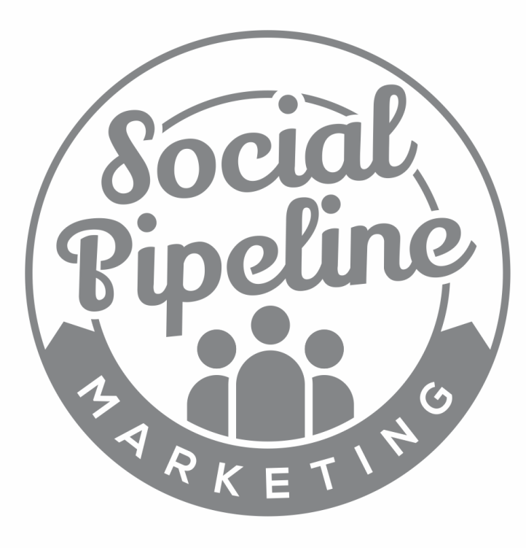

30 MINUTE
PER DAY
CHECK LIST

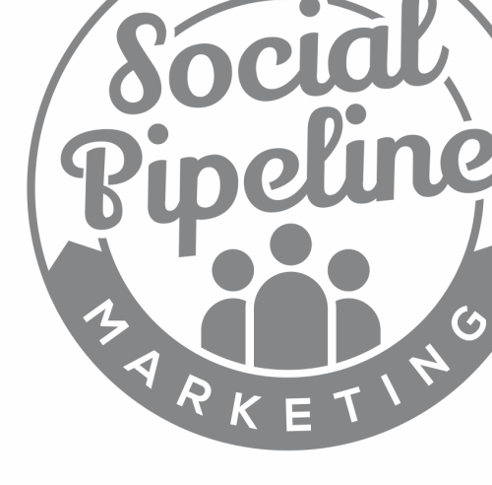
How To Use

This document highlights the tasks that I perform each day, which helps me to:
- Grow my following on Facebook, Twitter & LinkedIn
- Engage with my target market
- Attract leads into my Sales Funnel
- Develop stronger relationships with my Centres of Influence
Having a Daily Task List allows us to keep procrastination at bay, and ensure that we are focussed on our core objectives, which centres on generating leads and/or sales.
Use this template as a guide for your own daily activity.
Feel free to change and tweak it to your liking.

30 Mins Per Day Checklist

Twitter Activity
Task | Done? (tick)
Check ‘Notifications’ Tab
Reply to any outstanding conversations
Run searches to check for leads (or use Twilert?)
Have 5-10 conversations with leads or followers
Add Target Market w/ ManageFlitter
Perform the follow / unfollow routine
Interact with 5x Centres of Influence
Retweet / Reply / @Mention
Other:
Other:

Facebook Activity
Task | Done?
Check Updates / Notifications
Reply to any outstanding comments
Interact with 5x Centres of Influence
Monitor Facebook Advertising
Other:
Other:

LinkedIn Activity
Task | Done?
Check for Notifications
Reply to any outstanding comments
Like / Comment on a handful of status updates
Comment / Interact in 3x Groups
Add Target Market w/ Search Function
Follow Up with new Connections
Other:
Other:

Additional Time

Additionally, I would advise that you spend a little extra time, on the following activities:

Once Per Week: 45 – 60 Minutes
Content Creation – create content for the following week (Monday – Sunday) and schedule in HootSuite.

Review Competitors – scan over your ‘Competitors’ list in Twitter to review what your competitors are doing.

Once Per Month: 30 Minutes
Top Up Knowledge – educate yourself on any changes which may have occurred on the social media platforms you use.

Plan Monetisation Campaigns – schedule future competitions/special offers or other monetisation campaigns for future lead/sales generation.

Complete ‘Monthly Monitoring’ Table – fill in all columns within the Monthly Monitoring table to track and monitor the success of your campaign to date.

